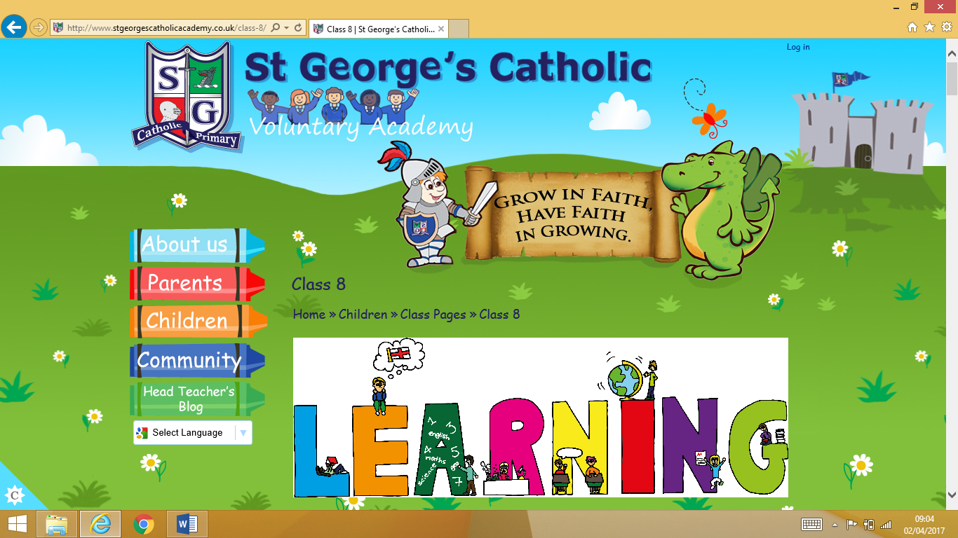**Upper Juniors Advent Term**

**Curriculum Letter**

**2025**

**Welcome!**

Welcome to the new academic year in Upper Juniors! We will be learning about lots of exciting things over the next term! In order to help you to get back into ‘the swing of things’ after what has been a very long break for some of you, we have gathered some information and reminders about our routines. If you have any further questions, please come and talk to us and we will do our best to help.

**Homework**

Homework will continue to be set on a weekly basis. It will be set on a Monday and collected in on the Friday. There will be reading and a piece of Maths and Literacy/Topic work to complete. We expect everyone to complete their homework on time and in their own handwriting. If there is anything that pupils do not understand, they should first ask an adult at home for help and then ask their teacher for help before Friday! We are more than happy to help!

**Spellings**

Learning spellings is very important in order for children to become confident writers, therefore we expect all pupils to revisit and learn their Year 5/6 spellings which are in the front of their homework book. We understand that some pupils may struggle more than others with spellings and we do not expect pupils to always get every single spelling right. Extra support will always be on hand and spelling sessions are tailored to the children’s needs. Children will bring home their Spelling books too on a Friday, for extra practice and these need to be returned on Monday.

**Reading**

Talk for Reading has made a huge impact on the enjoyment of reading. Children are also able to answer more in depth questions based on what they have read, which is fantastic! We will be continuing these reading sessions this term. Our first whole class reading for pleasure text of the year in Class 11 will be Girl of Ink and Stars by Kiran Millwood Hargrave. In addition to this, we expect every child to read at home to an adult **daily**. We do not want any of our children to fall behind with their reading, so it is vital that parents (or grandmas, granddads, older brothers/sisters) hear children read and ask questions about the book on a daily basis. I would like to take this opportunity to thank you for your co-operation with this in advance.

Parents should sign and date their child’s reading diary to show that they have heard their child read. They should also write which pages they have read and make a comment about how well their child has read, or if there are any difficulties. Here is an example below:

***12/09/25 – ‘The Wrong Side of Bed’. You used some good expression and could answer a range of questions. Read Pg56 to 63. J. Smith.***

We should see this five times a week. We reward children for each reading diary entry with a house point so make sure that each ‘read at home’ is recorded!

Last year we have formed a strong relationship with our local library on Blagreaves Lane where the children visit once a term. Children will have their Blagreaves Library numbers in the back of their reading diaries so you can take this to the library to take books out too at any time. You may get email reminders to take books back or renew them so please try to adhere to this. However, there is no charge for overdue books.

**English**

Our first topic of Talk for Writing’ this half term will be ‘Adventure stories’. The children have already carried out a cold task, which has allowed your child’s teacher to identify and plan precisely where they need to go next with their writing. At the end of the topic, pupils will do a hot task where they can showcase all of the new skills that they have learnt.

**Maths**

In Maths, pupils will be continuing their steps of the four operations as well as learn new skills involving shape, amounts, fractions and explaining data. They will also have the opportunity to take part in ‘dangerous maths’ sessions involving reasoning and problem solving throughout the week and especially on a Friday. The children should also be completing TTRS every night at home until they are fluent in their multiplication facts. Their password will be in the back of their reading diary.

**Topics**

This year, we will continue our three week rolling timetable to help us to deliver longer and more exciting science, arts and humanities lessons.

In Geography, our learning this year will continue to look at the world’s biomes and climate zones and ocean currents and we will continue to look at South America in more depth and begin to delve into the beauty and diversity of North America.

In History, we will recap all of our learning about Ancient Egypt, Vikings, Romans (Year 5 and 6) Victorians, Tudors (English Reformation) and Ancient Greece (Year 6) plus our new learning this year on World War II, Tudors (Exploration) and Early Islamic Civilisation.

Our RE topics will be: Creation and Covenant, Life Choices, Expectations and Judaism

As part of our PHSE curriculum, we will be continuing to use our brilliant One Decision scheme, which allows us to share scenarios with children, based around our topic for that week. The children make the decision about what action a certain character should take when faced with a problem (e.g. bullying, online purchases, British Values etc). The scheme then (very cleverly) shows the outcome of that decision; it also shares the alternative ending. This promotes excellent discussion in class. We will also continue with our RSE (Relationship and Sex Education) programme that is tailored for each year group. We separate the Y5s and 6s for these sessions. We also use this time slot to study Catholic Social teaching (Caritas) which allows us to look at and discuss our impact on our planet and the people on it.

**PE**

Our PE days will be on:

Class 10 – Tuesday and Wednesday

Class 11 – Tuesday and Friday

Class 12 – Tuesday and Friday

However, we will occasionally have PE activities outside of these times and so it is essential that children keep their PE kits in school every day. PE kit consists of: black tracksuit bottoms and hoodie (for winter) and blue shorts, a coloured house t-shirt, pumps and trainers. Long hair must be tied back and no jewellery should be worn for PE. Therefore, if your child wears earrings, please ensure that these are not worn on PE days. There will also be an opportunity to do swimming within PE lessons as this is also part of the KS2 PE Curriculum. We suggest that you take your children swimming during the summer holidays to get them used to the water before September if they have never been in a swimming pool before. During Healthy Fortnight in the Pentecost Term, the children will be taking part in ‘Bikeability’, therefore, we suggest that the children practice riding their bikes over the summer holidays.

**Walking home**

Please be aware that whilst in previous years, we have allowed year 6s to walk home from school independently, this year we will not be allowing this until the summer term. Our reasoning behind that is the risks currently posed by children from local secondary schools. During the course of the year 23/24 we received notifications from the police around organised fights where knives were to be used, in relatively close proximity to the school. In addition, we have had three separate occasions of road safety issues, including one of our year 6s actually being hit by a car on Blagreaves Lane. Safeguarding is at the centre of everything that we do, which is why we have made this decision. We thank you for your understanding and cooperation. This also means that Year 6s will not be permitted to bring their mobile phones to school until the summer term.

**Class Assemblies**

Each class will participate in a class assembly this term. Please see the school sway newsletter for the dates of your specific class and there is also a hive of information to keep yourself up to date with school news.

**Our ‘Golden Rules’**

At St. George’s we expect all children to be well behaved and ready to learn. Remember that each new term is a fresh start. Here is a reminder of our school rules so that you know what we expect from pupils.

* Treat other people how you would like to be treated.
* Keep your hands, feet and objects to yourself.
* Always do as you are told straight away.
* Play your part in keeping our school clean and tidy.
* If you have nothing nice to say – say nothing at all.
* Respect other people and their property.
* Walk around school quietly, on the left and in single file.

Finally, we hope that you have a great summer and are ready to work hard and have lots of fun learning new things in the new term with your new class mates and teachers!

Mr Holmes, Miss Clark (Class 10)

Mrs Webb, Mr Ablewhite, Ms Davis/Miss Clarke (1:1) Miss Pegg (1:1) (Class 11)

Mrs O’Brien, Miss Adams, (Class 12)