**St George’s Catholic Voluntary Academy**

“Grow in faith and have faith in growing.”

**Our Big Question**

**Who am I?**

|  |  |
| --- | --- |
| **Key Vocabulary and Definitions** | |
| **qualities** | A distinctive characteristic associated with what somebody is like as a person. |
| **talents** | Natural aptitudes or skills. |
| **unique** | The only one of its type. |
| **gifts** | A special ability. |
| **responsibility** | Something you are expected to do. |
| **dignity** | Being valued and respected for what you are. |
| **image** | Being like something or someone else. |
| **peacemaker** | A person who works proactively to promote peace and justice. |

[](https://www.google.co.uk/url?sa=i&rct=j&q=&esrc=s&source=images&cd=&cad=rja&uact=8&ved=2ahUKEwiMvsnZkN_eAhWDx4UKHbvbARQQjRx6BAgBEAU&url=https://www.vectorstock.com/royalty-free-vector/man-head-silhouette-profile-icon-vector-10076572&psig=AOvVaw21Ra-yezHZGyBWHauQMGvQ&ust=1542671314547973) **Ourselves**

**Key Skills**

* I can **make specific links** between the words of St Paul and the Christian’s call to holiness, and between Hosea 11: 1-4 and God as a loving parent. AT1 (i)
* I can **give reasons** for many actions by believers, such as Maximilian Kolbe, as a consequence of their belief in a call to holiness and using their talents. AT1 (iii)
* I can **make links** between beliefs about who I am, my talents and qualities, and how they affect behaviour. AT2 (i)
* I can **compare** most of my own and others’ ideas about questions of who I am and how I use my talents and qualities. AT2 (ii)
* I can **express a point of view** and **give a reason** for it, supporting it by **making links** to a different source. I can express a preference. AT3

**Key Knowledge**

* Christians are chosen by God.
* Christians are called to holiness and called to be **peacemakers**.
* We are created in the **image** of God – made to be like Him.
* The **uniqueness** of each person is a sign of God’s love.
* When you treat others well, you are treating God well. When somebody does something great for us, we encounter God.
* Mary is an example of trust in God we

can follow.

* Maximilian Kolbe is an example of

selflessness and love.



**Scripture**

Matthew 7:12 ‘Treat others how you would like to be

treated.’

Colossians 3: 12-17- *A Holy People*

Genesis 1: 26-31 *– Made to be like God – We should act and be like Jesus showed us.*

Colossians 3: 10-11- *Created by God to be like God*

Philippians 4: 4-9 *– God is very near*

Hosea 11: 1-4 *– My love for you is great – This scripture talks about God being like a parent – think of all the ways your parents love and care for you.*

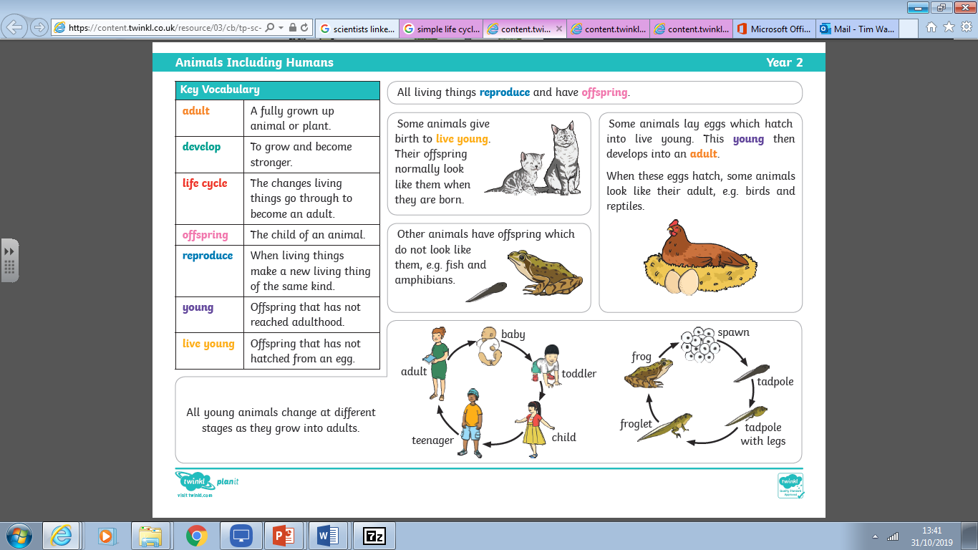

[](https://www.google.co.uk/url?sa=i&rct=j&q=&esrc=s&source=images&cd=&cad=rja&uact=8&ved=2ahUKEwiMvsnZkN_eAhWDx4UKHbvbARQQjRx6BAgBEAU&url=https://www.vectorstock.com/royalty-free-vector/man-head-silhouette-profile-icon-vector-10076572&psig=AOvVaw21Ra-yezHZGyBWHauQMGvQ&ust=1542671314547973)

[](http://www.awesomehealth.nl/wp-content/uploads/2017/01/Hart.jpg)

[](https://www.google.co.uk/url?sa=i&rct=j&q=&esrc=s&source=images&cd=&cad=rja&uact=8&ved=2ahUKEwi905bjkd_eAhUICRoKHa-0BdEQjRx6BAgBEAU&url=https://thenounproject.com/term/thought-bubble/56884/&psig=AOvVaw3VPdHr6y4KQ2lJ2PnK3GL7&ust=1542671619436930)

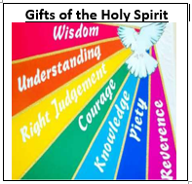

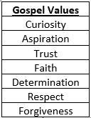

**Christian Beliefs**

**Prior Knowledge and Skills**

* I have made links between many religious stories, people in the community I have studies and their beliefs. I have made links to the belief of Trusting in God. In Year 3, I have learnt about many of St Paul’s letters.
* I have given reasons for many actions by believers.
* I have made some links to show how feelings and beliefs affect my behaviour and that others.
* I have been able to compare most of my own and other people’s ideas about questions that are difficult to answer.
* I have been able to express a point of view and give reasons for it, make a link to a source that supports a point of view and express a preference with reasons.

**Other Sources**

Footprints Poem

Prayer of St. Theresa of Avila

**Hymns**

I am who you say I am

Brokenness Aside

10,000 Reasons

My Lighthouse

**We are in Ordinary Time**

The colour for Ordinary Time is green. It is a time when we continue to grow in God’s love. Through the Gospels, we are journeying with Jesus on his mission.