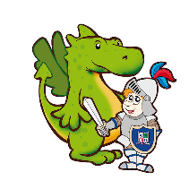

At St George’s, children show a passion for science through a well-sequenced and challenging curriculum. Children are given opportunities to develop the characteristics of scientists and explore, discuss and question to deepen their understanding of the world around them.

**Science can be seen in the real world and in different careers.**

**Teachers plan opportunities to address my misconceptions.**

**Pupils share learning with our community and engage in wider school opportunities**

**Pupils learn new things through engaging and stimulating lessons using a range of evidence based learning strategies .**

**There are opportunities for Science lessons to be taken outdoors.**

**Pupils discuss and develop their ideas through science talk.**

**Lessons build upon previous knowledge.**

**Pupils see themselves as a scientist.**

**Science teaching and learning is good at our school when:**

**Teachers make links across different curriculum subjects**